**BME Capstone Design Project Weekly Progress Report**

**Project Title:** KK01: Design of extremely small satellite

**Student Name:** Bethany Santos, Ho Yin Samuel Yeung, Owais Nakhuda

**Reporting Week:** Nov5 - 9

**Project Manager of the Week:** Ho Yin Samuel Yeung

**Tasks Outlined in Previous Progress Report:**

* Determine satellite payload ideas relating to Biomedical and Material Sciences
* Determine the feasability of designing a MOF Crystal Growth Analyzer Cubesat in space. How are MOFs characterized here? How are they synthesized? Are there any limitations we cannot get past? What is the cost of creating a MOF?
* Acquire consultant contacts for Material Science payload research

**Progress made in Reporting Week:**

* Ryerson Professors from chemical engineering were contacted (Dr. Zarrin, Dr. Cheng), and provided insight into current characterization methods for nanocrystaline-structures (the same type found in MOFs)
* Researched the process and feasibility to synthesis MOFs in house vs outsourced. A quote inquiry has been sent to moftechnologies.com to get pricing on three different synthesized MOFs.

**METHODS OF CHARACTERIZATION FOR METAL-ORGANIC FRAMEWORKS**

Thanks to information provided by Dr. Zarrin via phone call, modern methods of crystal characterization consist of either process: SEM mircroscope, or XRD Crystallography.

**What is SEM?**

Scanning Electron Microscopes use high energy electrons to create a high resolution image from the deflection pattern as the electrons hit the material surface. The general structure of an SEM consists of the following:

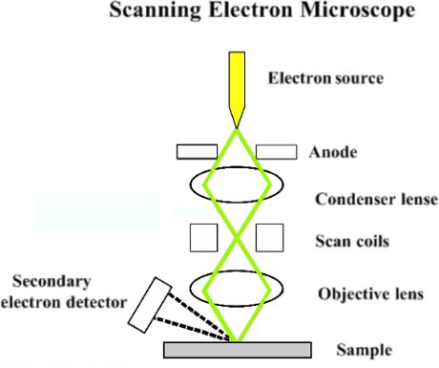

For our design considerations, we need only consider the hardware requirements of an SEM, and the commercial availability of an SEM unit. From the diagram, a general SEM consists of:

* an electron source (a hot cathode and anode to accelerate boiling surface electrons)
* A condenser lens (a set of coils meant to focus the stream into a smaller point)
* A set of scanning coils (meant to deflect the condensed stream to different points on the sample)
* A second lens (meant to refocus the stream at the sample)
* A secondary Electron detector (attracts the defelected electrons and converts the energy into a point of light to be recorded on)

Scanning Electron Microscopes require extreme precision in order to deliver the high resolution photos of the material sample. As a result, these instruments are not only expensive(~$5000), but large. As a result, it would not be a practical method of crystal characterization for our sample, as our maximum size is only 10x10x10cm.

In addition, the power requirements to operate the magnetic lensing along with the electron source goes well over 2W, which is the maximum power allowed on a cubesat. Therefore, it is not practical to implement SEM on our Cubesat Design.

**What is XRD Crystallography?**

XRD Crystallography is the method of characterizing crystal geometry through the use of Xray spectroscopy. In summary, the method consists of detecting the xray diffraction pattern of a sample as it is placed in an xray beam. By recording the difraction pattern across the entire surface of the crystal, an image for the crystalline structure can be generated. The sample being monitored must be no smaller than 0.1mm on all sides. A general Diagram for XRD Crystallography is as follows:

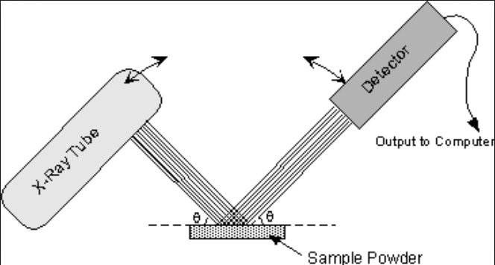

In general, in order to properly measure the diffraction pattern at one side of the material surface, the beam source must be placed 180 degrees from the detector. The beam angle of incidence is determined by the size of the sample.

For our design considerations, we need only consider the hardware requirements of an XRD, and the commercial availability of an XRD unit. From the diagram, a general XRD consists of:

* An xray source. This can be any of the following:
  + An xray tube consisting of an electron gun firing high energy electrons onto a metal anode made of tungsten.(most common)
  + A nuclear isotope (currently undetermined)
* A set of actuators to scan the material at different places
* An Xray Detector device to record the Diffraction Pattern. This can consist of

Currently, the smallest commercial solution for XRD Crystallography is a test-bench setup like the Rigaku Mini-flex 600 (which can be found in the RUAC). In addition, the power requriements for such instruments reuqires up 600W, considerably over the 2W limit of our cubesat design. As such, should XRD Crystallography be implemented, it must be a custom assembly.

Current X-ray Tube sources are not only expensive, but difficult to acquire in low-power and small footprints. The currentl smallest available Xray source comes from Xoft for cancer therapy 2.25mm length, with a diameter of 5.4mm. Disregarding high voltage power source needed to oeprate such a device, the input power is still above our maximum by 13W (15W vs. 2W). Therefore, it is currently impractical to implement an onboard xray source for our satellite.

Should it be required to implement such a payload design, one alternative would be to remove the xray generator and instead work with the high radiation environment of space as our xray source. Assuming even distribution of xray radiation across surface, the satellite must be able to receive the scattered difraction pattern throughout its surface. In this regard, the entire interior of the satellite would need to be installed with xray detectors. The most cost-effective approach would be to implement CCD camera modules on all interior sides of the satellite, and apply an xray window in front of the module in order to filter out the visible light. Issues of resolution and reliability vs. a regular camera have not been researched.

**SYTHENSIS OF MOFs**

The synthesis of MOFs involve submerging the organic and in-organic substances in a solvent then supplied with high energy to form crystalize. Below lists the different types of methods to synthesize MOFs, the duration of synthesis, and the percent of MOFs synthesized using the various methods.

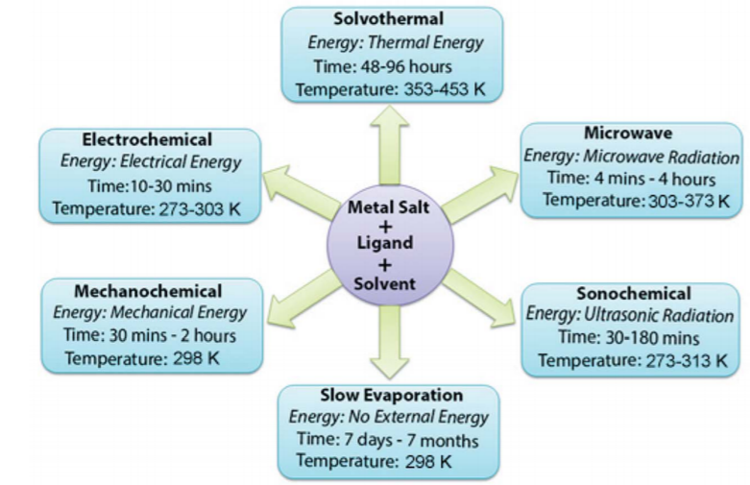

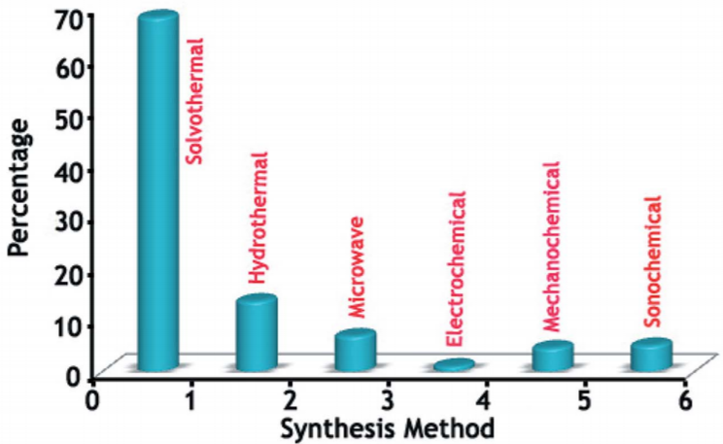

Since solvothermal is the method most commonly used, this method will be the main method for the possible preparation of the MOF. Solvothermal synthesis is carried out in a closed vessel undergoing autogenous pressure from the solvent above its boiling point. Most common solvents used are dimethyl formamide (DMF), diethyl formamide (DEF), acetonitrile, acetone, ethanol, methanol**.** The vessel is then transported to a thermal chamber to be heated at high temperatures for 2-4 days. The temperature can range from 80 to 180 degrees celsius depending on the solvent used and the reaction requirement.

Overall, the method is simple requiring raw substances to be synthesized, vials, pipettes, and access to a thermal oven for a fews days. Depending on the accessibility to these materials which can be provided by the chemical engineering department, this method is feasible.

Buying MOFs already crystalized can save a lot of time during prototype and testing. A quote for three different 10g crystalized MOFs is pending from moftechnologies.com to be compared with in-house synthesis method in to determine the most feasible approach.

**Tasks for Next Week:**

* Conduct further research into Material Science Payload measurement options
* Finalize Payload for satellite

**SOURCES:**

<http://blog.phenom-world.com/what-is-sem>

<http://www.chem.ucla.edu/~harding/ec_tutorials/tutorial73.pdf>

<https://physics.stackexchange.com/questions/64656/how-can-we-detect-x-rays>

<https://www.osti.gov/servlets/purl/751018>

<https://www.xoftinc.com/assets/X-Ray-Source-The-Xoft-System.pdf>

<https://www.nature.com/articles/srep45472>

<https://pdfs.semanticscholar.org/38cb/2da4ac2b62ee9b8be9939fa4720aa1487808.pdf>

<http://www.moftechnologies.com/products/>

Zea, Luis, Microbiological Experiments for Onboard CubeSats - A Review and Prospects

<https://www.frontiersin.org/articles/10.3389/fmicb.2018.00310/full?fbclid=IwAR1Hkvepe4Z5XqJvM0ec-P4ybaZICvsxcbOL5AquyfneOwkObfPkzuU4jrk>